# Codebase

CSC 6360 Assignment 3

FanPage App

Following is the link to the GitHub repo for the fan page codebase - <https://github.com/pbaba1/MobileAppDevelopment>(Folder name: fanpage)

# Platforms used –

The application is built for the following platforms

1. Web application
2. Android mobile application

# Screenshots of the application

1. 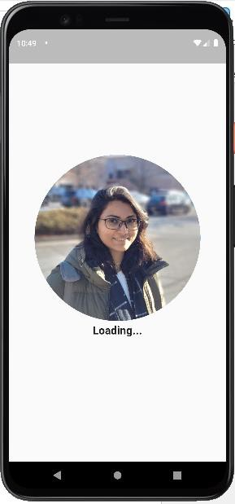Splash Screen –
2. Login Screen –

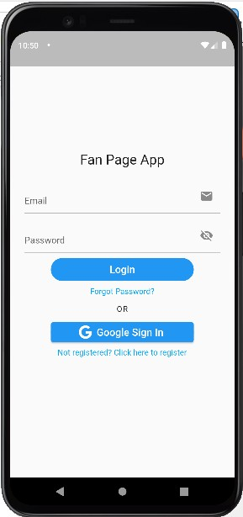

1. 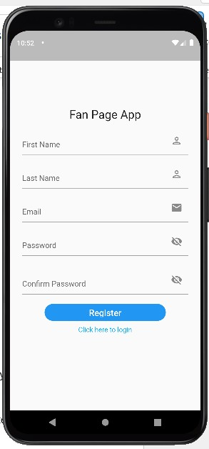New User Registration Screen –
2. Posts Listing screen –
   1. Since the user is an ADMIN, the user can see the + icon at the bottom right of the screen.

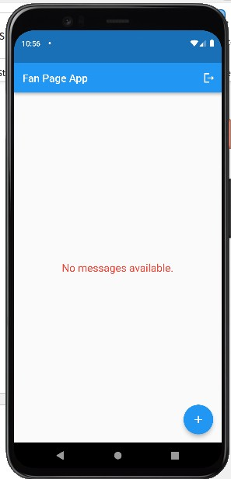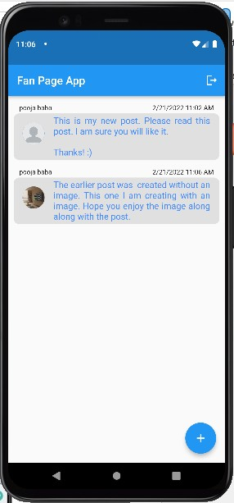

1. Create post screen –

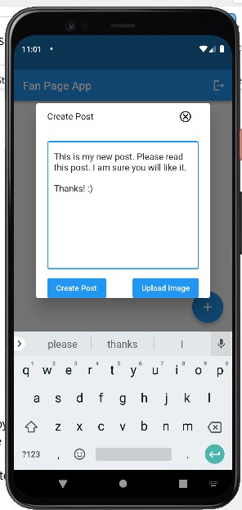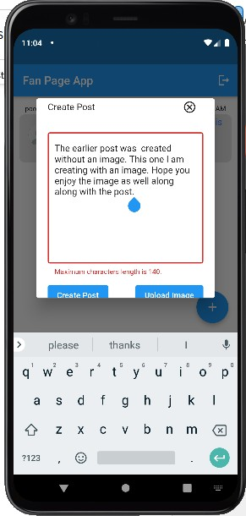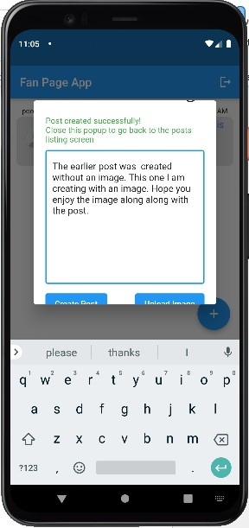

1. Logout screen –

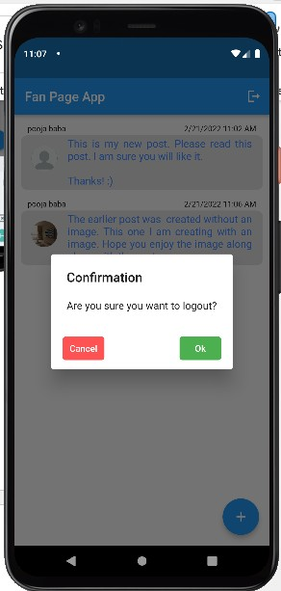

1. 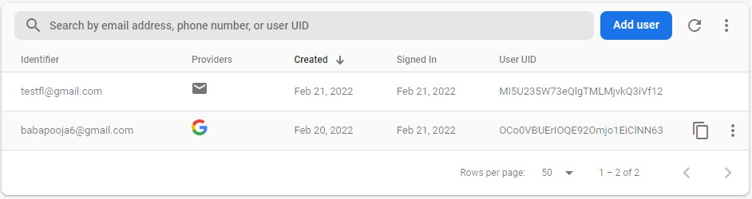Firebase Authentication –
2. Firestore Database –

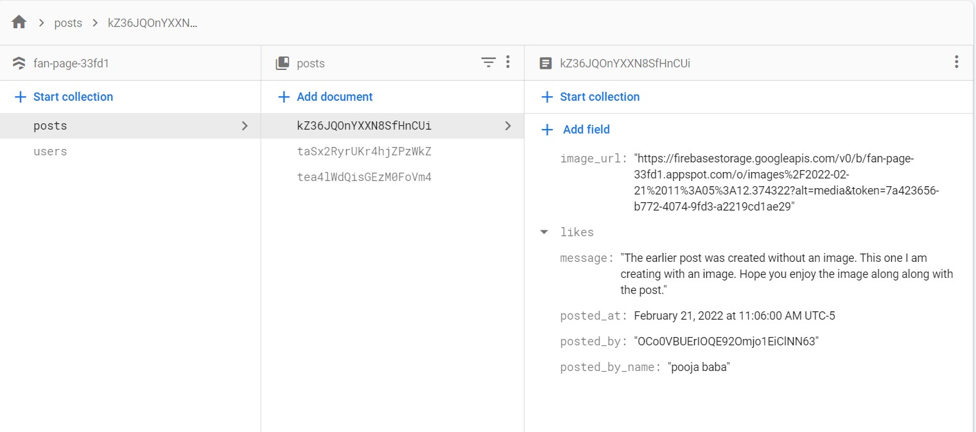

1. Storage –

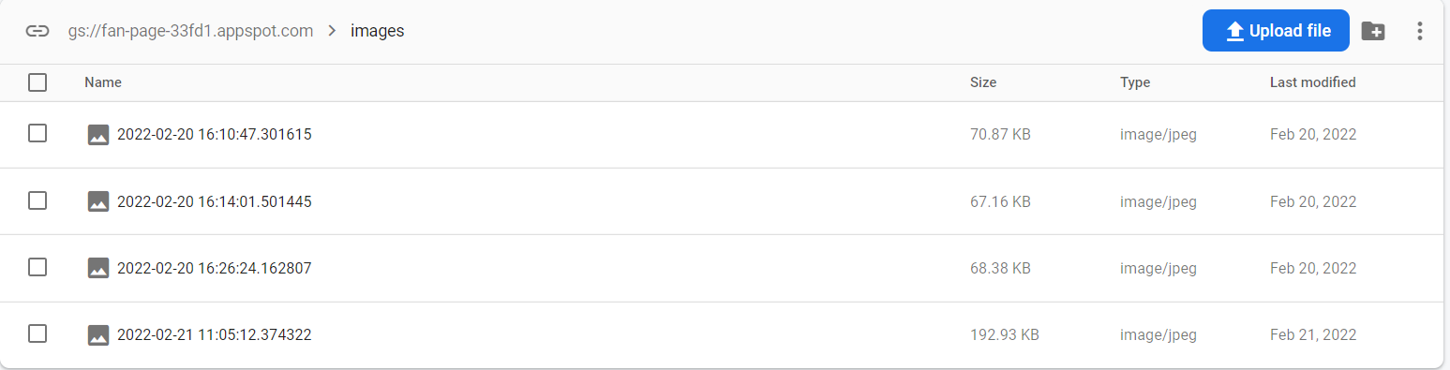

# Features Implemented

1. Login feature –

Using the login feature user will be able to login into the application, by entering the email address and password that the user had used to create the account for the application.

1. User Registration feature –

Using this feature users will be able to register into the application by entering the details as shown in the above screenshot #3.

1. Google sign-in feature-

Using the Google sign-in feature users will be able to sign up using a Google account and later on sign into the application using the Google credentials.

1. Forgot Password feature -

This feature will enable users to reset the password if the user has forgotten their user ID.

1. Home screen posts listing feature-

Once the user has used one of the above features to enter their application, the user will be landed on the home screen of the application where the user will be able to view all the posts created by the admin. the posts will have a default image displayed. if the admin had uploaded any multimedia to the post while creating one then that image will be displayed in the listing section.

1. Create Posts feature –

Once the user has logged into the application based on the role assigned to the user that is admin or user will be able to view a button at the bottom of the screen as shown in image number 4. clicking on this button the user will be able to view a popup which will allow one to create a post and post it to the database. while creating this post users can choose multimedia by clicking on the upload image button as displayed in the above screenshot #5.

1. Logout feature-

If the user wishes to log out of the application the user can do so by clicking on the logout icon at the top right corner of the app bar. upon clicking on the logout button, the user will be prompted a confirmation dialog box. on this dialog box if the user clicks on the **OK** button user will be logged out of the application and navigated to the login page. if the user cancels the activity, the user will stay on the home screen.

1. Upload image feature-

This feature is implemented with the help of firebase’s Storage.

1. Firestore database-

This is a NoSQL database. It has two collections in it as follows: -

* 1. 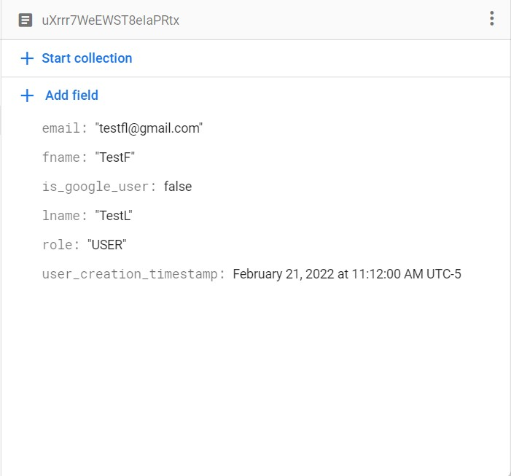*Users* – The structure of which looks like as shown in the below image
  2. 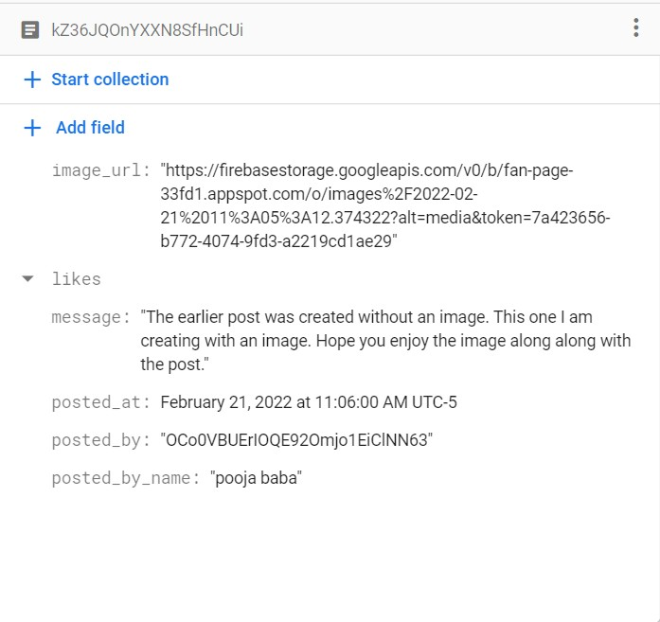*Posts* – The structure of which looks like as shown in the below image

## Note

To execute the web application, we need to run it with the following command –

flutter run -d chrome --web-hostname localhost --web-port 5000